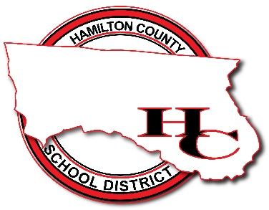

Attention Families!
Hamilton County Schools are now taking payments online!
Pay when it’s most convenient for you with a computer or mobile device at https://hamiltonfl.revtrak.net. This district Web Store even integrates with Skyward!
Save time and be confident that your payment makes it where it needs to go. You can pay online with debit or credit cards, or with electronic checks.
Hamilton County Schools are currently accepting online payment for fees like these:

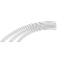
Plus....

Visit https://hamiltonfl.revtrak.net to pay fees online.
Skyward Student Fees
Skyward Food
Spiritwear, GradBash, Gradventure, yard signs, and any other
school-related fees!

Skyward Payments Made Easy

Visit the Web Store
Visit https://hamiltonfl.revtrak.net and click Log in or create your personal Web Store account to make payments for your student’s Skyward Food and Fees account.

Make Payments to your Skyward Account

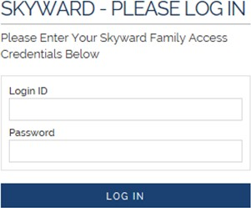
If you haven’t previously logged in to Skyward, you will need to enter your student’s credentials. The student will show in the future, when logged in to the Web Store.

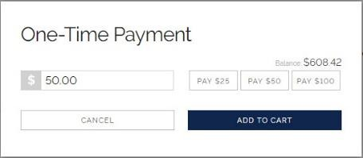
To make food payments, click on Make a One-Time Payment under the desired student’s name.

Enter your amount or choose a quick pay option: $25, $50, $100. Select Add to Cart.
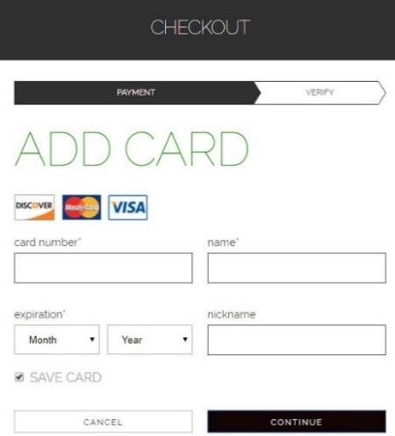
Proceed to checkout or continue shopping.

Enter your billing information and click Continue.

After verifying your information, click Place Order to process your transaction and view your receipt.

Payment will be processed and receipt can be viewed and printed. A receipt will automatically be sent to the email address provided. Receipt can be viewed at any time through your account settings.

